
COUNCIL ASSESSMENT REPORT
NORTHERN REGIONAL PLANNING PANEL

PANEL REFERENCE & DA NUMBER | PPSNTH-77 DA21/0010
PROPOSAL | Concept Staged Development Application for a Rural Land Sharing Community and associated works over 21 lots which are to be subdivided into 11 lots to allow for 392 dwelling plots over 10 lots to create 10 interconnected Rural Land Sharing Communities (the remaining lot will contain all of the RU5 Village zoned land).
ADDRESS | Lot 4 DP 737440 & Lot 2 DP 1235488, No. 2924 Kyogle Road; Lot 34 DP 755714, No. 2956 Kyogle Road; Lot 121 DP 134446, Lot 1 DP 390311, Lot 5 DP 282299, Lot 2 DP 582300, Lots 1-2 DP 611556, Lots 3, 8, 19, 22, 31-33, 35 DP755714; Lot 1 DP 1183098; Lot 11 DP 1194471 No. 2984 Kyogle Road, Kunghur; Lot 20 DP 755714 & Lot 2 DP 1148316, No. 3222 Kyogle Road, Mount Burrell and unnamed Crown Road reserves
APPLICANT | Kempcove Pty Ltd, NCV Enterprises Pty Ltd, Peter Van Lieshout, Dolph Cooke, Darko Kovac, Zimmer Land Pty Ltd
APPLICATION TYPE (DA, Concept DA, MOD, INTEGRATED, DESIGNATED) | Concept DA
REGIONALLY SIGNIFICANT CRITERIA | The applicant lodged the Development Application as regional development in accordance with Schedule 7 clause 2 General development over $30 million and Schedule 7 clause 5 Private infrastructure and community facilities over $5 million of State and Regional Development) 2011. The applicant claimed that the Development Application had a CIV of $37 million and also that the development proposed private infrastructure works exceeding $5 million.  Council sought legal advice which concluded that several items listed in the CIV value are not part of the proposal and consequently reduces the CIV value to below the $30 million threshold. The applicant agreed that these items were not to be included and removed them from the CIV and increased the value of other items. The applicant has adjusted the CIV to $39,850,000.
KEY SEPP/LEP | Relevant environmental planning instruments  Tweed Local Environmental Plan 2014  SEPP No. 55 - Remediation of Land  SEPP (Infrastructure) 2007  SEPP (State and Regional Development) 2011  SEPP (Primary Production and Rural Development) 2019  SEPP (Koala Habitat Protection) 2020  Relevant development control plan  A2-Site Access and Parking Code  A3-Development of Flood Liable Land  A5-Subdivision Manual  A19-Biodiversity and habitat management
CIV | The applicant has adjusted the CIV to $39,850,000.
RECOMMENDATION | Refusal
DATE OF REPORT | 15 July 2021
SCHEDULED MEETING DATE | Select Date

Assessment Report and Recommendation

FILE NO: DA21/0010

REPORT TITLE:
Development Application DA21/0010 for a staged concept development application under s4.22 of the EP&A Act 1979 for multiple rural land sharing communities with stage 1 seeking approval for the upgrade of the existing private road and associated earthworks, vegetation removal and site construction office and storage area at Lot 4 DP 737440 & Lot 2 DP 1235488, No. 2924 Kyogle Road; Lot 34 DP 755714, No. 2956 Kyogle Road; Lot 121 DP 134446, Lot 1 DP 390311, Lot 5 DP 282299, Lot 2 DP 582300, Lots 1-2 DP 611556, Lots 3, 8, 19, 22, 31-33, 35 DP755714; Lot 1 DP 1183098; Lot 11 DP 1194471 No. 2984 Kyogle Road, Kunghur; Lot 20 DP 755714 & Lot 2 DP 1148316, No. 3222 Kyogle Road, Mount Burrell and unnamed Crown Road reserves

SUMMARY OF REPORT:
Council has received a Concept Staged Development Application for a Rural Land Sharing Community and associated works over 21 lots which are to be subdivided into 11 lots. Importantly, the application does not propose the construction of dwellings. Stage 1 of the Concept Development Application involves relatively minor works relating to private internal road works located at Access 2. All works are located within private property and do not undertake works within the Kyogle Road Reserve.
The site has an area of 1584.34 ha consisting of mainly land zoned RU2 Rural Landscape with an area zoned RU5 Village and minor area zoned W1 Natural Waterways under the Tweed Local Environmental Plan 2014. The application seeks approval for 392 dwelling plots over 10 lots to create 10 interconnected Rural Land Sharing Communities (the remaining lot will contain all of the RU5 Village zoned land). The application was lodged with a claimed Capital Investment Value (CIV) of $37 million (which exceeds the $30 million threshold) which would require the Development Application to be determined by the Northern Regional Planning Panel in accordance with Schedule 7 Regionally Significant Development, State and Regional Development 2011.
Council sought a legal opinion (provided in the confidential attachments) from a Senior Counsel on two matters relating to the Development Application. In summary the advices conclude that:
• Costs associated with site sewer, rainwater tanks and solar systems should be excluded from the calculation of the CIV for the proposed development (therefore a CIV of $21,918,830.00 plus 15% contingency), and
• The proposed development is prohibited on a number of grounds.
At that point it followed that it was the Council (not the Panel) which was the consent authority for the proposed development. Furthermore, because the proposed development is prohibited the Council did not have the power to grant it development consent.
The applicant was advised of Council’s position and was requested to withdraw the application. The application was not withdrawn. The Northern Regional Panel (NRPP) and the Department of Planning, Industry and Environment were also advised of Council’s position.
On 16 June 2021, a revised CIV estimate was submitted (provided in the attachments). The revised CIV is $39,850,000. Items that were previously contended by Council such as: water tanks, septic tanks and solar systems have been removed. Costings for road works have been revised and bridges have now been included. Whilst there is limited detail on items such as bridges in the development application the revised CIV is taken on face value and rather prolong conjecture about the CIV it is recommended to continue the application on the pathway of Regional Development.
The Development Application was referred externally to: Natural Resources Access Regulator, Heritage, Community Engagement – Department of Premier and Cabinet, NSW Rural Fire Service, Department of Planning Industry & Environment - Biodiversity and Conservation Division. All of the agencies either required further information or did not support the proposal. The Biodiversity and Conservation Division advised that they estimate the proposed development would require extensive land clearing of approximately 106 ha of native vegetation with a further 220 ha of impact in native populations and areas described as ‘cleared/grassed paddocks with scattered trees, regrowth and weed thickets’. The cost of Biodiversity Offsets required to offset the loss of biodiversity values to enable the proposed development is estimated in excess of $27 million.
SEPP 55 Remediation of Land clause 7
Insufficient information has been provided to determine if SEPP 55 has been satisfied.
This assessment report has revealed that the application should be refused for the following reasons:
1. The proposal is not consistent with Schedule 5 of the Primary Production and Rural Development SEPP, as the development is not development on a single lot for 3 or more dwellings contrary to clause 4(1)(a) of Schedule 5 and is therefore prohibited (Section 4.15 (1)(a)(i) of the Environmental Planning & Assessment Act 1979);
2. The proposal is not consistent with Schedule 5 of the Primary Production and Rural Development SEPP, as the development on each lot relies on development on other lots contrary to clause 4(1)(a) of Schedule 5 and is therefore prohibited (Section 4.15 (1)(a)(i) of the Environmental Planning & Assessment Act 1979);
3. The proposal is not consistent with the aims in clause 2(a) and 2(c) of Schedule 5 of the Primary Production and Rural Development SEPP, as the development:
(a) proposes to undertake subdivision to create lots for interconnected rural land sharing and is therefore prohibited under clause 4(1)(g) of Schedule 5;
(b) creates unacceptable undue harm to the environment and is therefore prohibited under clause 4(1)(g) of Schedule 5 (Section 4.15 (1)(a)(i) of the Environmental Planning & Assessment Act 1979);
4. The proposal is not consistent with Schedule 5 of the Primary Production and Rural Development SEPP, as the development is in breach of the cap on population density in clause 7 of Schedule 5 to the SEPP (Section 4.15 (1)(a)(i) of the Environmental Planning & Assessment Act 1979);
5. The proposal is not consistent with Schedule 5 of the Primary Production and Rural Development SEPP, as the development is on land that is a wildlife corridor contrary to clause 4(1)(d) of Schedule 5 to the SEPP and is therefore prohibited (Section 4.15 (1)(a)(i) of the Environmental Planning & Assessment Act 1979);
6. The proposal is not consistent with Schedule 5 of the Primary Production and Rural Development SEPP, as an Aboriginal Cultural Heritage Assessment of the surrounding land has not been undertaken and therefore consent cannot be granted because Council is unable to take into account the heritage characteristics of the land and surrounding land as required by clause 5(c) of Schedule 5 to the SEPP (Section 4.15 (1)(a)(i) of the Environmental Planning & Assessment Act 1979);
7. The proposal is considered to create significant environmental impacts on both the natural and built environments, due to significant amount of native vegetation removal and impact on native fauna (Section 4.15 (1)(b) of the Environmental Planning & Assessment Act 1979);
8. The site is considered not to be suitable for the proposal due to the existing constraints (Section 4.15 (1)(c) of the Environmental Planning & Assessment Act 1979);
9. The proposal is considered not to be in the public interest due to the high impact on the environment and cultural heritage, the isolated location and the absence of a coherent management strategy for capital and recurrent funding of proposed infrastructure and environmental management (Section 4.15 (1) (e) of the Environmental Planning & Assessment Act 1979);
10. Insufficient information has been submitted with the Development Application to enable an assessment of the impacts of the proposal (Section 4.15(i)(b)).

REPORT:
Applicant: NCV Enterprises Pty Ltd
Owner: Kempcove Pty Ltd, NCV Enterprises Pty Ltd, Peter Van Lieshout, Dolph Cooke, Darko Kovac, Zimmer Land Pty Ltd
Location: Lot 4 DP 737440 & Lot 2 DP 1235488, No. 2924 Kyogle Road; Lot 34 DP 755714, No. 2956 Kyogle Road; Lot 121 DP 134446, Lot 1 DP 390311, Lot 5 DP 282299, Lot 2 DP 582300, Lots 1-2 DP 611556, Lots 3, 8, 19, 22, 31-33, 35 DP 755714; Lot 1 DP 1183098; Lot 11 DP 1194471 No. 2984 Kyogle Road Kunghur; Lot 20 DP 755714 & Lot 2 DP 1148316, No. 3222 Kyogle Road Mount Burrell and unnamed Crown Road reserves
Zoning: RU2 - Rural Landscape, W1 – Natural Waterways and RU5 – Village
Cost: The applicant revised the CIV dated 16 June 2021 $39,850,000

Background:
The site has an area of 1584.34 ha consisting of mainly land zoned RU2 Rural Landscape with an area zoned RU5 Village and minor area zoned W1 Natural Waterways. The site consists of 21 existing lots with multiple structures and uses, which consist of several dwellings, farmland, plantations, camp grounds, cabins, Rural shed, internal roads. The site contains three access points on to Kyogle Road, and borders Mebbin National Park to the west.
The proposal seeks approval for 12 stages to develop the site, the stages are as follows:
Stage 1 – Involves relatively minor works relating to private internal road works located at Access 2. All works are located within private property and do not undertake works within the Kyogle Road Reserve.
Future Stage 2 – Subdivide the existing 21 lots into 11 lots and establishing essential service infrastructure.
Future Stages 3-12 – Identify specific dwelling plots and detailed studies on plot and locational specifics.

Site Diagram:
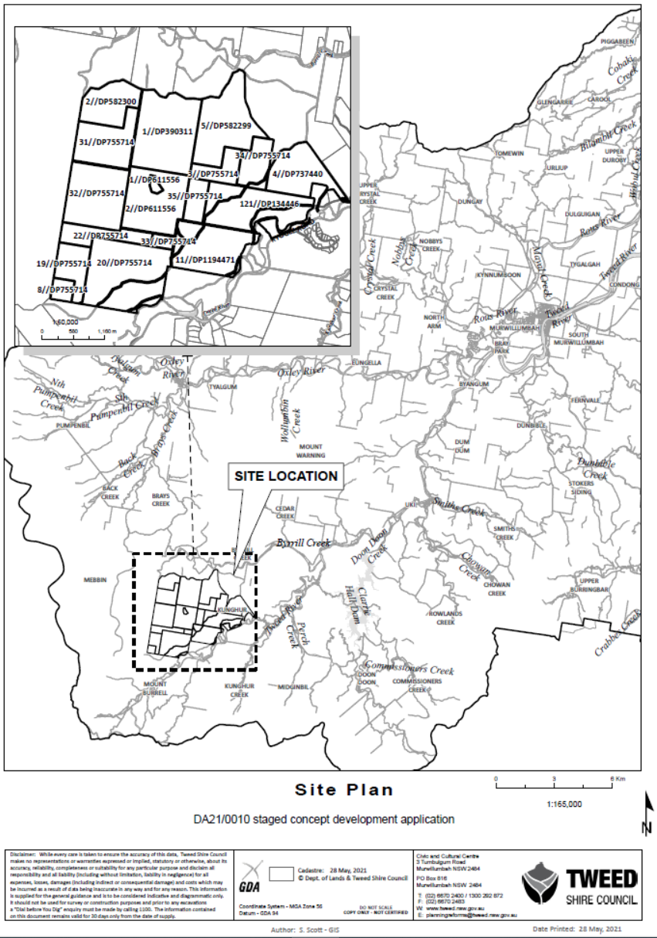
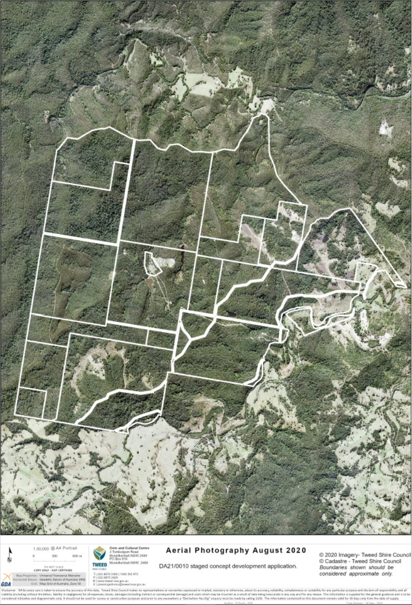

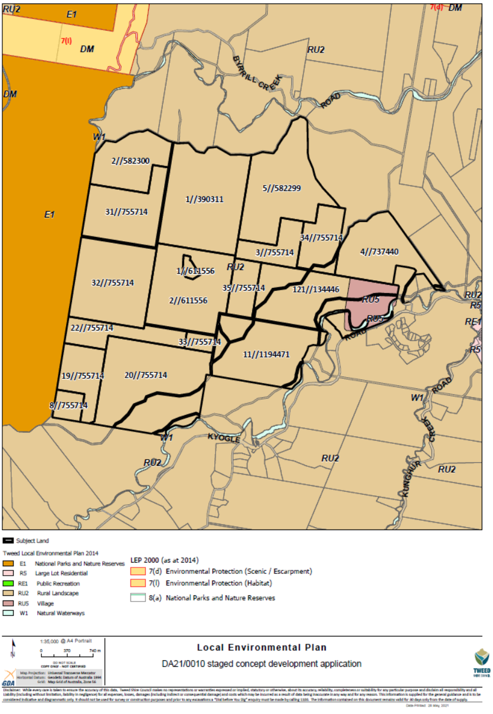
DEVELOPMENT/ELEVATION PLANS:

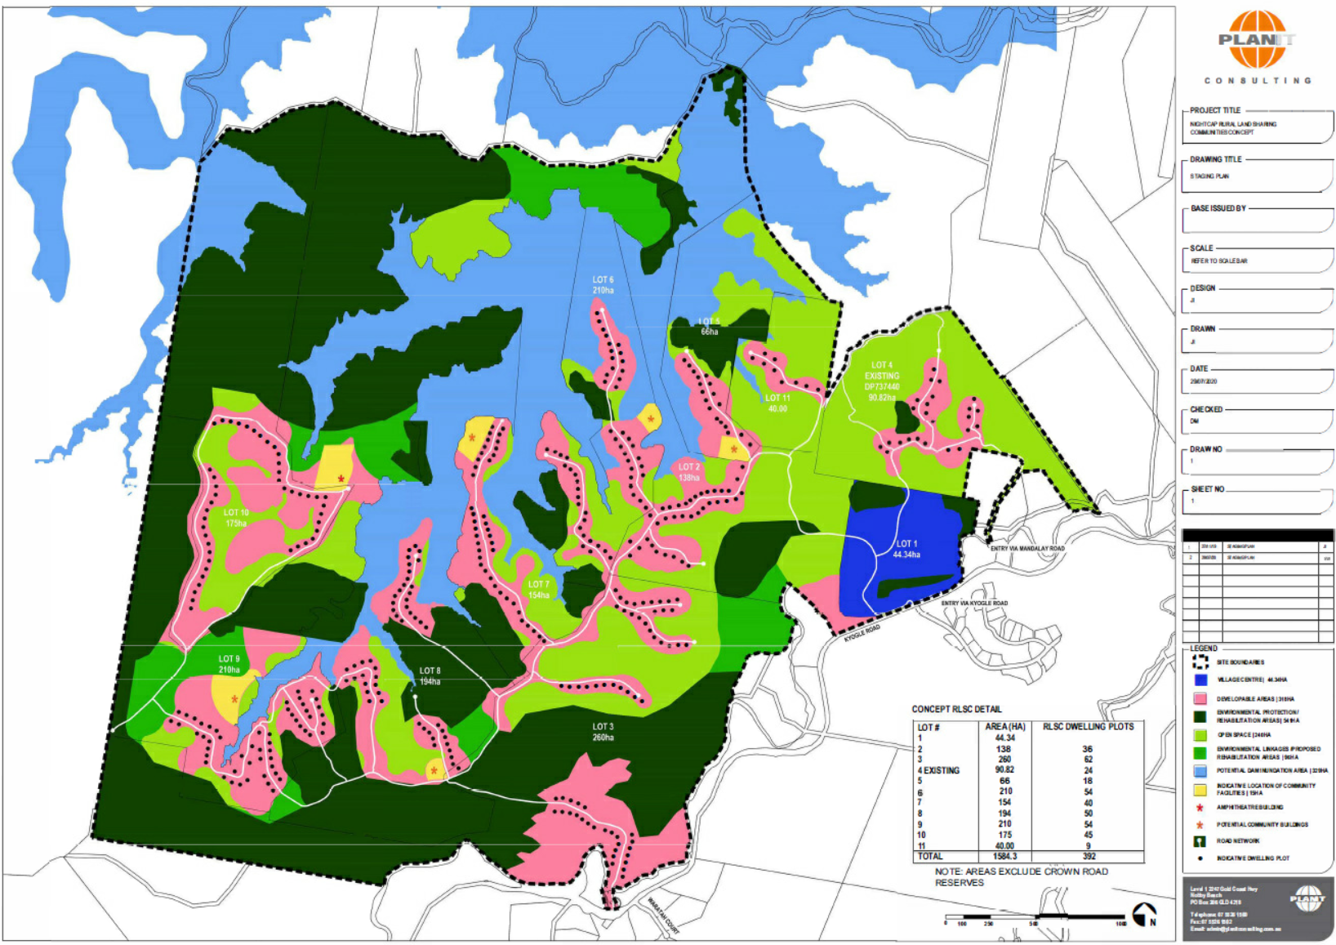
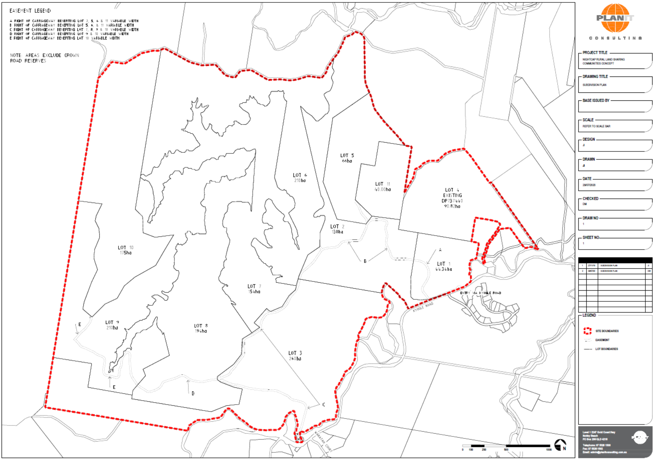

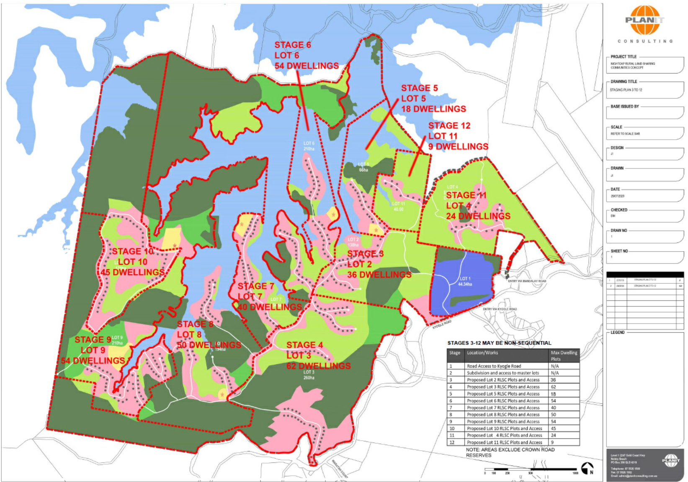

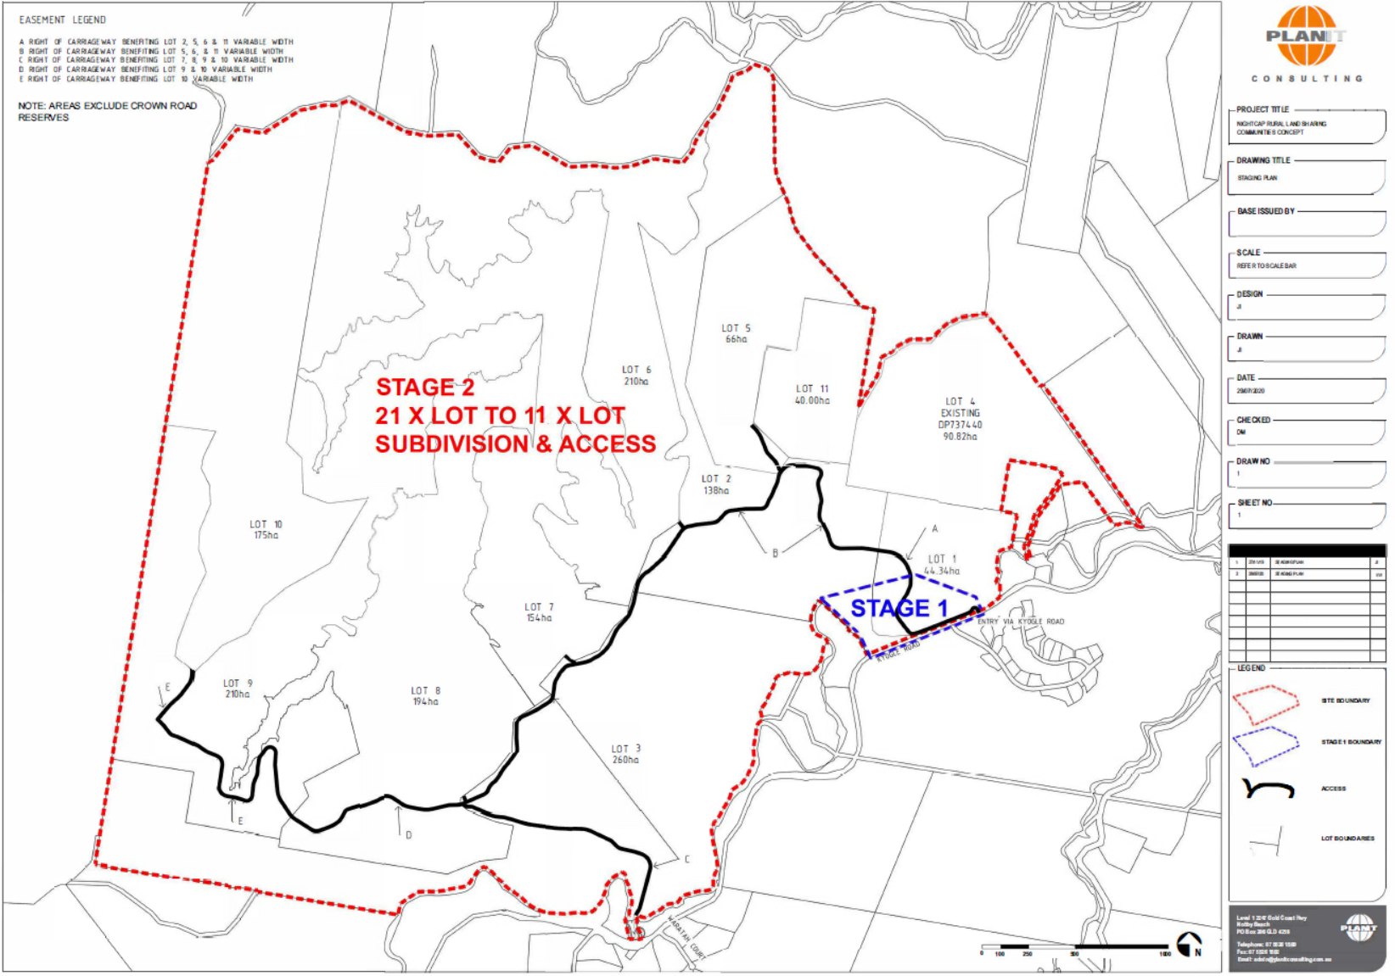

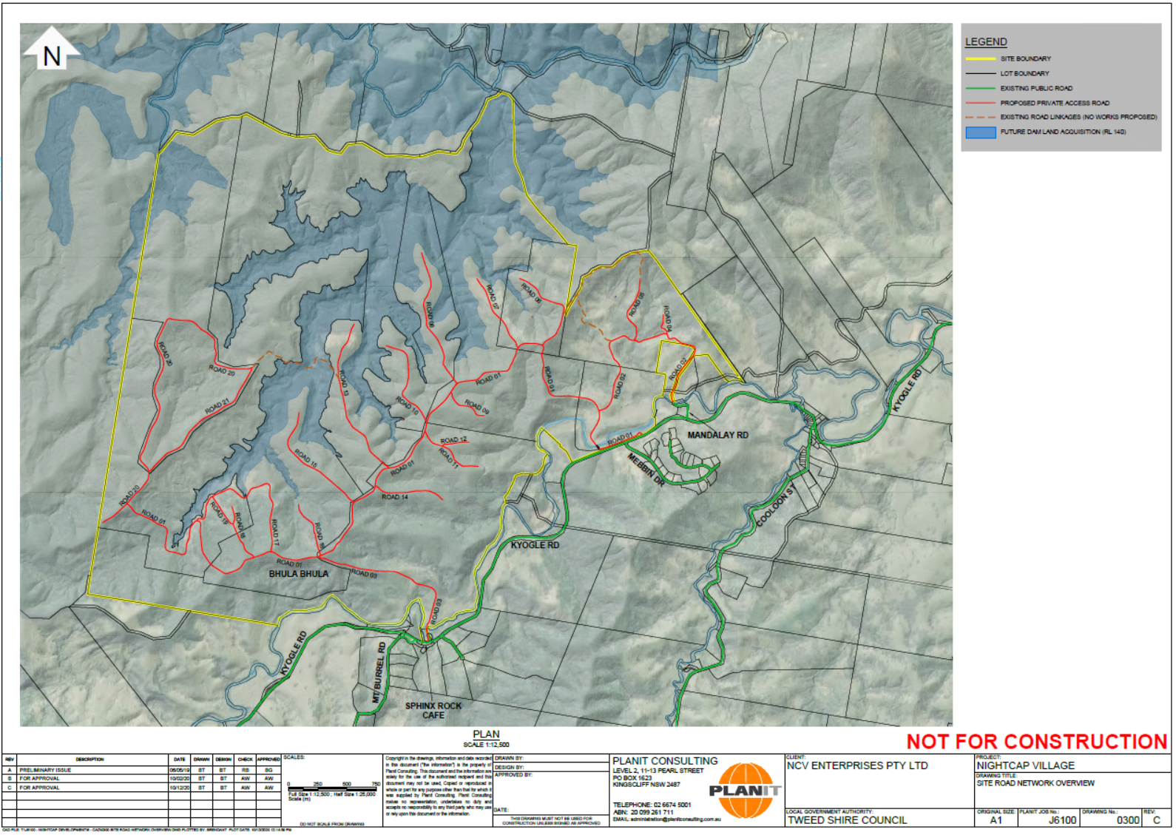

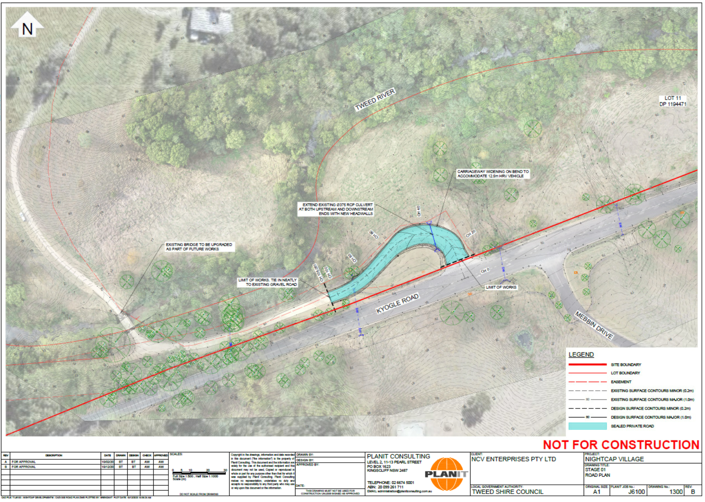

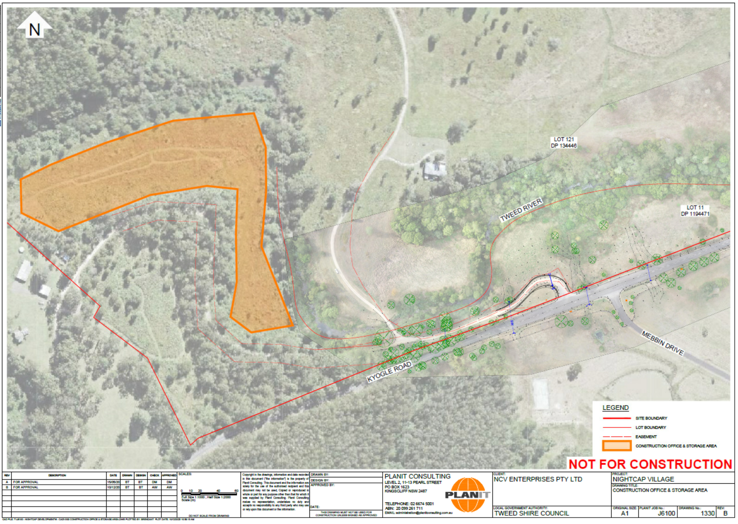

Considerations Under Section 4.15 Of The Environmental Planning And Assessment Act 1979:

(a) (i) The provisions of any environmental planning instrument

Tweed Local Environmental Plan 2014

Clause 1.2 - Aims of the Plan

The proposal is considered not to be consistent with the aims of the plan. The proposal is considered to create significant impact on the natural and environmentally sensitive areas, cultural heritage, areas of high ecological value and Koala habitat.
1.2 Aims of Plan
(1) This Plan aims to make local environmental planning provisions for land in Tweed in accordance with the relevant standard environmental planning instrument under section 3.20 of the Act.
(2) The particular aims of this Plan are as follows—
(aa) to protect and promote the use and development of land for arts and cultural activity, including music and other performance arts,
(a) to give effect to the desired outcomes, strategic principles, policies and actions contained in the Council’s adopted strategic planning documents, including, but not limited to, consistency with local indigenous cultural values, and the national and international significance of the Tweed Caldera,
(b) to encourage a sustainable local economy and small business, employment, agriculture, affordable housing, recreational, arts, social, cultural, tourism and sustainable industry opportunities appropriate to Tweed,
(c) to promote the responsible sustainable management and conservation of Tweed’s natural and environmentally sensitive areas and waterways, visual amenity and scenic routes, built environment, and cultural heritage,
(d) to promote development that is consistent with the principles of ecologically sustainable development and to implement appropriate action on climate change,
(e) to promote building design which considers food security, water conservation, energy efficiency and waste reduction,
(f) to promote the sustainable use of natural resources and facilitate the transition from fossil fuels to renewable energy,
(g) to conserve or enhance the biological diversity, scenic quality and geological and ecological integrity of Tweed,
(h) to promote the management and appropriate use of land that is contiguous to or interdependent on land declared a World Heritage site under the Convention Concerning the Protection of World Cultural and Natural Heritage, and to protect or enhance the environmental significance of that land,
(i) to conserve or enhance areas of defined high ecological value,
(j) to provide special protection and suitable habitat for the recovery of the Tweed coastal Koala.

Clause 2.3 – Zone objectives and Land use table

The site contains the following zones: RU2 – Rural Landscape, W1 – Natural Waterways and RU5 – Village. It is to be noted that the development area is confined to land zoned RU2 Rural Landscape, with the plots not proposed within the RU 5 or W1 zones.
The proposal is considered prohibited as the proposal seeks a form of multi dwelling housing which is not permissible. The development is also considered not to be consistent with the objectives of the RU2 zone by not maintaining the rural landscape character of the land.

Clause 4.1 to 4.2A – Principal Development Standards (Subdivision)

The development proposes subdivision of the existing 21 lots to create 11 lots. All 11 lots are proposed to be equal to or greater than 40ha which complies with the minimum lot size development standard.

Clause 4.3– Height of Buildings

The site has a maximum 10m height limit where the dwelling plots are proposed (as measured from ground level existing to the highest point of the building). The development does not propose any buildings therefore this clause is not applicable.

Clause 4.4 – Floor Space Ratio

The site does not have a FSR where the dwelling plots are proposed therefore this clause is not applicable.

Clause 4.6- Exceptions to development standards

The applicant does not seek any exceptions to development standards.

Clause 5.4 – Controls relating to miscellaneous permissible uses

Not applicable.

Clause 5.10 – Heritage Conservation

The site is not identified as being of environmental heritage, heritage item or heritage conservation area. The site is identified as being of both predictive Aboriginal Cultural Heritage and known Aboriginal Place of Heritage Significance. The application was referred to the Tweed Byron Local Aboriginal Council (TBLAC) for comment. TBLAC provided the following comments:
“There are three AHIMS registered sites within the footprint of the Stage 1 works which all date back to a 1998 archaeological survey Some earthworks have recently been done on the access track which is within or adjacent to the Stage 1 area. On April 13, in the area that has been disturbed (which is, in effect, a very small ‘sample’ of the area) we located 20 artefacts. Clearly the area is very rich in Aboriginal Objects which are protected by legislation. Numerous new artefacts that were located during our surveys of the broader project area in January and March 2019”.
“Whilst it is currently a pre-emptive conclusion, subject to the results of the on-site meeting and agreed actions, TBLALC’s recommendation in regard to Stage 1 will be that a comprehensive archaeological investigation be undertaken of the area of Stage 1, which will most likely require or result in an application for an AHIP, prior to any substantial ground disturbance. Alternatively, the proponents may decide to withdraw and / or modify their plans in order to avoid harm to Aboriginal cultural heritage. In any case, currently we recommend that the DA for Stage 1 not be further considered by Tweed Shire Council.
Additionally, although it is not yet ‘on the table’ as far as we are aware, TBLALC does not consider that any development plans for the wider land sharing community project in the area should progress without much more detailed Aboriginal cultural heritage assessment. To be clear, whilst we have participated in the assessments of the area that have contributed to the ACHA to-date, we consider this to be a ‘first-pass’, which did nevertheless identify a large number of ACH objects. The abundance of ACH Objects in the area identified by the first-pass assessment cautions all concerned for much greater scrutiny of the area. At this stage TBLALC is of the opinion that any proposed development of the larger project area which will involve any ground disturbances will require further site-specific assessments in the future approval processes.”

Clause 5.11 – Bush fire hazard reduction

The site is identified as being prone to bushfire, the application provided a Bushfire Management Plan which was referred to the NSWRFS. NSWRFS advised that “As per the current referred documents, the NSW RFS cannot support the Concept Plan application. The proponent will need to provide the following additional information to enable a detailed assessment of the Concept Plan…”

Clause 7.1 – Acid Sulfate Soils

Acid Sulfate Soils is considered unlikely to be a constraint for the proposal.

Clause 7.2 – Earthworks

Inadequate information has been provided which clearly details the extent of earthworks proposed.

Clause 7.3 – Flood planning

The site is in the uppermost reaches of the Tweed River and Byrrill Creek. Council does not hold detailed flood studies for these areas. The site contains the Tweed River, creeks and gullies however the location of the dwelling plot sites are most likely above flood events.
Additional information is requested in relation to the three access crossing over the Tweed River and that the community is likely to be isolated by road during flood events. Even if the internal road network is flood free the external is not. How will the community maintain self-sufficiency during time of flood isolation? In particular, what services will be available onsite to support residents during periods were external services are unavailable? Should a resident require medical attention during flood isolation, how will this be accessed?

Clause 7.5 – Coastal risk planning

The subject land is not identified as being subject to coastal risk.

Clause 7.6 – Stormwater Management

The development impervious areas would be negligible relative to the site area. Each future dwelling is to be in a rural context with plenty of land area for the distribution of stormwater. Each future dwelling will also have rainwater collection tanks installed for potable water supply. The proposed 392 dwellings do not represent a concern from a stormwater quality or quality.
The SWMP notes “28km of road widening from 2m to 6m”. This represents a 3 x increase of the unsealed road area, which requires some consideration from an erosion and sediment perspective. The SWMP outlines measures to mitigate ESC risks associated with the proposed road network in accordance with Erosion and sediment control on unsealed roads by the NSW Government Office of Environment and Heritage (now DPIE). This is generally considered an appropriate approach for the site and nature of development.

Clause 7.7 – Drinking Water Catchments

The site is within a Drinking Water Catchment and therefore this clause is applicable, th relevant clauses are provided below.
(3) Before determining a development application for development on land to which this clause applies, the consent authority must consider the following—
(a) whether or not the development is likely to have any adverse impact on the quality and quantity of water entering the drinking water storage, having regard to the following—
(i) the distance between the development and any waterway that feeds into the drinking water storage,
(ii) the on-site use, storage and disposal of any chemicals on the land,
(iii) the treatment, storage and disposal of waste water and solid waste generated or used by the development,
(b) any appropriate measures proposed to avoid, minimise or mitigate the impacts of the development.
(4) Development consent must not be granted to development on land to which this clause applies unless the consent authority is satisfied that—
(a) the development is designed, sited and will be managed to avoid any significant adverse impact on water quality and flows, or
(b) if that impact cannot be reasonably avoided—the development is designed, sited and will be managed to minimise that impact, or
(c) if that impact cannot be minimised—the development will be managed to mitigate that impact.the application relies on future Development Application to determine the impacts on water storage areas.
There is insufficient information to determine if the development will avoid any significant impact on the water quality.

Clause 7.8 – Airspace operations

The development is considered unlikely to impact on airspace operations. The site is not located within the Gold Coast Airport or the Murwillumbah Airfield.

Clause 7.9 – Development in areas subject to aircraft noise

The development is not located in an area subject to aircraft noise.

Clause 7.10 – Essential Services

All essential services are made available to the subject site subject to future Development Applications.

State Environmental Planning Policies

SEPP (North Coast Regional Environmental Plan) 1988

SEPP No. 55 - Remediation of Land

Insufficient information has been provided to determine if SEPP 5 has been satisfied.

SEPP (Infrastructure) 2007

The application was referred to Transport for NSW in accordance with clause 104 Traffic Generating Development and Schedule 3 Traffic Generating Development to be referred to Transport for NSW, as the proposal exceeds the threshold of residential accommodation with access to a classified road (Kyogle Road). The Department advised that it required the following additional information in order to complete their assessment:
1. TfNSW notes that Austroads channelised right-turn (CHR) and auxiliary left-turn (AUL) treatments are appropriate for T-intersections, however the TIA does not sufficiently consider the suitability of these treatments within context of available sight distances and in relationship to existing intersections. The final location and treatment of proposed intersections should be informed by a clear timeline for staging of the proposed development and timing of associated transport demands.
It is recommended that Council request strategic drawings for each proposed intersection with the classified road to inform scope, cost and constructability. These drawings should identify available sight distances in all directions and swept paths analysis for relevant design vehicles, including any public transport. This will provide a level of certainty that all future works needed to support the Concept Plan are achievable.
2. TfNSW notes that this assessment does not consider the safety of existing access arrangements for the final development. The following points are noted;
• Proposed ‘Access 1’ is located at the existing intersection of Mandalay Road, which appears
to have limited sight distance to and from the West. The available Safe Intersection Sight
Distance (SISD) in both directions is not identified in the assessment.
• Proposed ‘Access 2’ is an existing staggered T-intersection generating conflict between
through and right turning vehicles. The existing delineation of this intersection does not appear
to consistent with Austroads Guidelines
• Proposed ‘Access 3’ is a proposed new intersection and available sight distances have been
assessed against an observed 85th percentile speed of 68km/h. Any assessment needs to
consider available sight distances for the posted speed limit of 80km/h.
TfNSW recommends the Consent Authority be satisfied of the Road Safety Assessment has
demonstrated that the proposed access locations can accommodate the Concept development.

SEPP (State and Regional Development) 2011

The applicant lodged the Development Application as regional development in accordance with Schedule 7 clause 2 General development over $30 million and Schedule 7 clause 5 Private infrastructure and community facilities over $5 million of State and Regional Development) 2011. The applicant claimed that the Development Application had a CIV of $37 million and also that the development proposed private infrastructure works exceeding $5 million.
Council sought legal advice from Senior Counsel on the CIV aspect of this Development Application given its importance as a jurisdictional issue for the determination of the Development Application. The advice that Council received analysed the concept Development Application and the various items that form the CIV and concluded at the time that several items listed in the CIV value are not part of the proposal and consequently reduced the CIV value to below the $30million threshold. As a result of this on 16 June 2021, a revised CIV estimate was submitted (provided in the attachments) by the applicant.
The revised CIV is $39,850,000. Items that were previously contended by Council such as: water tanks, septic tanks and solar systems have been removed. Costings for road works have been revised and bridges have now been included. Whilst there is limited detail on items such as bridges in the development application the revised CIV is taken on face value and rather prolong conjecture about the CIV it is recommended to continue the application on the pathway of Regional Development and refer this assessment to the Northern Regional Planning Panel for determination.
Accordingly, the application is regional development and therefore Northern Regional Planning Panel is the consent authority.

SEPP (Primary Production and Rural Development) 2019

The application is proposed under schedule 5 Rural land sharing communities of the SEPP.
Council sought legal advice from Senior Counsel on the Development Application and its’ permissibility. The advice primarily concludes that the development set out in this concept Development Application is prohibited.
The provisions of the schedule is as follows:
2 Aims of Schedule
This Schedule aims to encourage and facilitate the development of rural land sharing communities committed to environmentally sensitive and sustainable land use practices by—
(a) enabling people who collectively own a single lot to erect multiple dwellings on that lot without dividing the lot (such as by subdivision or by contractual arrangements), and
(b) enabling the sharing of facilities and resources to allow a wide range of communal rural living opportunities at a lower cost, and
(c) facilitating development on rural land (preferably in a clustered style) without undue harm to the environment and without creating a demand for the unreasonable or uneconomic provision of public amenities or services, and
(d) creating opportunities for an increase in rural population in areas that are experiencing population loss.
The proposal is considered not to be consistent with clause 2(a) of the aims of the Schedule as the lots are interconnected not a single lot. The proposal is considered not to be consistent with clause 2(c) of the aims of the Schedule as the proposal is considered to unacceptable harm to the environment due to the significant level of fauna and flora loss, the site being isolated from services and the impact on cultural heritage.
3 Land to which Schedule applies
This Schedule applies to land in any rural zone but not to the following land—
(a) land in an environmentally sensitive area for exempt or complying development within the meaning of clause 3.3 of the Standard Instrument,
(b) land to which a wilderness protection agreement under the Wilderness Act 1987 relates,
(c) land that is a forestry area within the meaning of the Forestry Act 2012,
(d) land that is within a special area or a controlled area under the Hunter Water Act 1991, the Sydney Water Act 1994 or the Water NSW Act 2014.
4 Rural land sharing community permitted with consent
(1) The consent authority may grant development consent to development on land to which this Schedule applies for the purposes of 3 or more dwellings if satisfied of the following—
(a) the land is a single lot with an area of not less than 10 hectares,
(b) the height of any building on the land will not be more than 8 metres,
(c) no more than 25% of the land is prime crop and pasture land and no building containing a dwelling will be on any such land,
(d) no building will be on land that is a wildlife refuge, wildlife corridor or wildlife management area and the development will not adversely affect any such land,
(e) the development will not include a camping ground, caravan park, eco-tourist facility or tourist and visitor accommodation, except where otherwise permissible on the land,
(f) no building will be on land that has a slope in excess of 18 degrees or that is prone to mass movement,
(g) the development is consistent with the aims of this Schedule.
It is considered that the proposal is not consistent with clause 4 as dwellings are not proposed and the land is not a single lot as development involves multiple lots that are interconnected. The proposal is considered to be inconsistent with the clause as the site contains a wildlife corridor which runs through the site with roads and dwelling plots located over. As discussed within this report above the proposal is considered not to be consistent with the aims of the clause as required by clause 4.1.g.
5 Matters to be considered
The consent authority must not grant development consent under this Schedule unless it has taken into account the following—
(a) the arrangements for operating and managing the community,
(b) the design of the proposed development,
(c) the physical and heritage characteristics of the proposed site and surrounding land,
(d) the availability of roads, utilities and other services,
(e) the impact of the development on the environment and any present or future use of the land,
(f) any other matter that the consent authority considers to be relevant.
Insufficient information has been provided which details how the development is to operate and managing the community, the heritage characteristic of the proposal and surrounding land, availability of utilities and services and impact of the development in the environment.
6 Future management
The consent authority must not grant consent to development under this Schedule unless it is satisfied that adequate provision will be made for the following—
(a) water and waste management,
(b) prevention, control and management of soil erosion,
(c) bush fire management,
(d) flora and fauna management, including the control of noxious weeds and noxious animals,
(e) provision and maintenance of internal roads, boundary fences, water reticulation, service corridors for telephone and electricity cables and similar matters.
Insufficient information has been provided in regards to bushfire management, flora and fauna management and the maintenance of internal roads, fencing and services.
7 Density of development
(1) The consent authority must not grant consent to development under this Schedule if the development would result in more than the following number of dwellings on the land—
(a) if the land has an area of 10 hectares or more but not more than 210 hectares—4 dwellings plus 1 additional dwelling for every 4 hectares of land greater than 10 hectares,
(b) if the land has an area of 210 hectares or more—54 dwellings plus 1 additional dwelling for every 6 hectares of land greater than 210 hectares up to a maximum of 80 dwellings.
(2) The consent authority must not grant consent to development under this Schedule if the development would result in the number of persons reasonably accommodated in all the dwellings on the land being greater than 4 times the maximum number of dwellings otherwise permitted by this clause.
The proposal does not comply with the density provisions provided in clause 7.
8 Subdivision prohibited
Subdivision (other than a subdivision permitted under clause 2.75 of State Environmental Planning Policy (Exempt and Complying Development Codes) 2008) of land is prohibited if development has been carried out on the land under this Schedule or under provisions similar to this Schedule.
Note—
For example under the former State Environmental Planning Policy No 15—Rural Landsharing Communities.
There should be no application for a strata certificate under this Schedule as subdivision is prohibited.
Not applicable at this stage. Only applicable if development has been carried out.
9 More than 1 dwelling may be treated as a single dwelling
The consent authority may, for the purposes of this Schedule, treat 2 or more dwellings as a single dwelling if it is satisfied that, having regard to the sharing of any cooking or other facilities and any other relevant matter, the dwellings comprise a single household.
The proposal does not propose dwellings.

SEPP (Koala Habitat Protection) 2020

The SEPP (Koala Habitat Protection) 2020 was published on the 30 November 2020. Section 7 of the policy identifies land to which the policy applies
Land to which this Part applies
This Part applies to land—
(a) that is land to which this Policy applies, and
(b) that is land in relation to which a development application has been made, and
(c) that, whether or not the development application applies to the whole, or only part, of the land—
(i) has an area of more than 1 hectare, or (ii) has, together with adjoining land in the same ownership, an area of more than 1 hectare.
The policy applies to the subject site.
Based on the ecological information provided with the submitted application material, Council cannot be satisfied that the subject site does not support:
a) Potential Koala Habitat in accordance with Section 8 of the policy; and
b) Core Koala Habitat in accordance with Section 9 of the policy
It is noted that whilst the applicant has not specifically identified whether Preferred Koala Habitat and Core Koala Habitat (as defined in the policy) exists on the land, at pp. 66 of the Statement of Environmental Effects dated December 2020 Version 5 prepared by Planit Consulting the following comment is made:
The proposed Stage 1 works do not remove any significant koala vegetation nor trigger the requirement of a Koala Plan of Management. As such, a Koala Plan of Management (KPoM) will be prepared at the first subdivision DA (Stage 2). The future KPoM will respond to relevant legislation as required and as in effect at the time.
The application has not been accompanied by a Koala Plan of Management.
Accordingly, Council consent cannot be granted in the absence of further survey, assessment detail and where required, a site specific individual Koala Plan of Management.
With respect to use of the site by Koala and extent of potential habitat the following information can be taken from the submitted Biodiversity Development Assessment Report (BDAR) dated November 2020 prepared by Planit Consulting:
• Units of vegetation classified in the BDAR as Pink Bloodwood – Tallowwood moist open forest of the far northern ranges of the NSW North Coast Bioregion (PCT 1073) comprise Schedule 2 - Feed tree species of the policy being Eucalyptus microcorys (Tallowwood). The BDAR at pp. 42 specifically identifies E. microcorys as a co-dominant canopy species as follows:
1
2 The canopy is co-dominated with Pink Bloodwood (Corymbia intermedia), Tallowwood (Eucalyptus microcorys), White Mahogany (E. acmenoides), Grey Ironbark (E. siderophloia) and Grey Gum (E. propinqua) which are the indicator species within the canopy layer for this PCT
• Eucalyptus microcorys (Tallowwood) was identified within 22 of the 40 vegetation data plots.
• Habitat polygons for Koala were applied to all areas of PCT 812 Zone 1, PCT 812 Zone 2 and PCT 1073 Zone 1 - Refer to Figure 16 of the BDAR.
• The proposed development envelope encompasses vegetation units assigned a Koala habitat polygon. Those habitat units are proposed to be directly impacted in order to facilitate the development. Refer to Figure 16 of the BDAR
• Koala was recorded onsite by the following survey method and trace evidence (Refer to Appendix 2 Fauna Survey Data of the BDAR):
o Observed and heard call
o Camera
o Tracks, scratching,
o Scat
• In appendix 3 of the BDAR the following was noted with respect to Koala:
Recorded – The Koala was recorded within eucalypt forests of the site on several occasions. Although no mothers with young was observed, it is considered likely that breeding occurs within the subject site given its size and connectivity to expansive areas of bushland
(a) (ii) The Provisions of any Draft Environmental Planning Instruments

There are not draft LEPs applicable.

(a) (iii) Development Control Plan (DCP)

Tweed Development Control Plan

A1-Residential and Tourist Development Code

The development does not propose any dwellings.

A2-Site Access and Parking Code

Access
There are three (3) proposed points of access for the site off Kyogle Road which already exist, refer to the figure below.
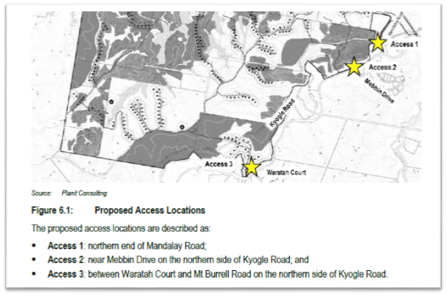
Stage 1
Stage 1 of the concept Development Application involves relatively minor works relating to private internal road works located at Access 2. All works are located within private propoerty and do not undertake works within the Kyogle Road Reserve.
Access 1
No works are proposed at this intersection or upon Mandalay Road for the current Development Application, however upgrades works will be required for the future stages and development applications.
Additional information is required for Access 1 in relation to the road width and bridge upgrade. Future stages will increase the number of vehicles which will require the access to be widened and the bridge to be upgraded. The current road reserve width is 9.8m, however Council’s requirements would require a road reserve width of 20m. This is problematic as the land on either side of the existing road reserve is not owned by the applicant and would require land acquisition from an unrelated party. It is noted that an assessment of sight distance requirements was not undertaken for Access 1.
Access 2
No works are proposed to this intersection as part of the Stage 1 Development Application. The works proposed at Access 2 are entirely internal for Stage 1. Proposed works at some future stage includes a bridge upgrade and access upgrade.
Access 3
The close proximity of the bridge to the proposed access with its proposed upgrade is of concern. The TIA recognises this but simply suggests that further investigation is required for future stages of the proposed development. Further investigation may result in such matters as an upgrade to the bridge being needed or a relocation of the access in order to fit in the proposed intersection treatment.
Additional information is required in relation to the intersection analysis which needs to be extended to show the extent that any works to be carried out in the future will involve an upgrade of the bridge immediately to the east.
Details should include the extent of the upgrade, concept engineering plans, costs and timeframes for carrying out an upgrade.
Parking
Adequate area is available on site for parking relating to stage 1 internal road works.
Future parking requirements will be assessed at each future stage.

A3-Development of Flood Liable Land

The site is in the uppermost reaches of the Tweed River and Byrrill Creek. Council does not hold detailed flood studies for these areas. The site contains the Tweed River, creeks and gullies however the location of the dwelling plot sites are most likely above flood events.
Additional information is requested in relation to the three access crossing over the Tweed River and that the community is likely to be isolated by road during flood events. Even if the internal road network is flood free the external is not. How will the community maintain self-sufficiency during time of flood isolation? In particular, what services will be available onsite to support residents during periods were external services are unavailable? Should a resident require medical attention during flood isolation, how will this be accessed?

A5-Subdivision Manual

The concept subdivision of the exiting 21 lots into 11 lots at Stage 2 is not appropriate for rural land sharing and is prohibited in accordance with Schedule 5 Rural land sharing communities of SEPP Primary Production and Rural Development 2019.

A19-Biodiversity and habitat management

The Tweed DCP A19 applies. In addition, the proposal exceeds the NSW Biodiversity Offsets Scheme threshold under the Biodiversity Conservation Act 2016 (BC Act) requiring the preparation of a Biodiversity Development Assessment Report (BDAR). A Biodiversity Development Assessment Report dated November 2020 prepared by Planit Consulting accompanied the application.
Assessment of the application is required under both DCP A19 and the BC Act.
The Department of Planning, Industry & Environment – Biodiversity Conservation Division (BCD) completed a review of the BDAR and other application material following brief site inspection with Council officers on the 31 March 2021. Review comments provided in the form of a submission were forwarded to Council on the 13 May 2021. In summary, the BCD concluded that the proposed development:
• would require extensive land clearing of approximately 106 ha of native vegetation with a further 220 ha of impact in native populations and areas described as ‘cleared/grassed paddocks with scattered trees, regrowth and weed thickets’
• does not demonstrate an ‘avoid’ approach to biodiversity impacts but would rather result in a very high biodiversity offset requirement
• would result in over 390 rural residential lots being located along unsealed roads with associated environmental impacts (allowable clearing activities, bushfire hazard requirements, effluent disposal, road construction and maintenance, water quality, and impact of domestic pets on native fauna’
• is not consistent with the aims and specific requirements of the State Environmental Planning Policy (Primary Production and Rural Development) 2019 for rural land sharing communities.
In addition, the BCD submission raised a number of serious deficiencies and discrepancies with the BDAR including but not limited to the following matters:
• The status and metes and bounds of identified timber plantation areas;
• Assessment of plantation areas in terms of biodiversity impact particularly where there is evidence of threatened fauna using the planted vegetation as habitat;
• Unallocated units of vegetation to a Plant Community Type namely those units identified as ‘Cleared Areas / grassed paddocks with scattered regrowth trees, regrowth and weed thickets’ (297 ha) and ‘Camphor laurel dominated closed to open forest’ (5.6 ha);
• Potential inappropriate location of flora survey plots positioned within eco-tonal areas or across edges;
• Inadequacy of fauna survey effort and applied methodology;
• Exclusion of two candidate threatened fauna species - Common Planigale (Planigale maculata) and Brush-tailed Phascogale (Phascogale tapoatafa) in the absence of targeted survey. Exclusion of Rufous Bettong (Aepyprymnus rufescens) as a candidate fauna species. Under representation of Southern Myotis (Myotis macropus) habitat polygons;
• Lack of information and inconsistency between statements made in reports and submitted plans relating to the protection, rehabilitation/treatment and management of a) Environmental Protection/Rehabilitation Areas b) Open Space c) Environmental Linkages/Proposed Rehabilitation Areas;
• Impact upon serious and irreversible flora species including Green-leaved Rose Walnut (Endiandra muelleri subsp. bracteata) and Scrub Turpentine (Rhodamnia rubescens);
• Anomalies with serious and irreversible fauna species assessment;
• Inadequate consideration of prescribed impacts;
• Impact on water-quality and lack of waterway buffers;
• Impact of the development on the adjoining Mebbin National Park; and
• No assessment of flora and fauna entities listed under the Commonwealth Environment Protection and Biodiversity Conservation Act 1999
The Sustainability & Environment Unit of Council similarly raise issue with those biodiversity matters identified in the BCD submission and concur with the BCD conclusions.
In terms of DCP A19 assessment and relationship with the BC Act, Section 7.13(6) of the BC Act allows Council’s to determine their own avoid and minimise standards. The DCP A19 aims, objectives and development envelope controls sets out the requirements to avoid and minimise the environmental impacts of development.
Those high conservation value ‘red flagged’ elements and associated ecological buffers supported onsite (based on reporting in the BDAR) to be avoided, protected and appropriately managed include the following:
• Listed Ecological Communities:
o Lowland Rainforest in the NSW North Coast and Sydney Basin Bioregion listed as an Endangered Ecological Community under the Biodiversity Conservation Act 2016 (BC Act)
o Lowland Rainforest of Subtropical Australia listed as a Critically Endangered under the Environment Protection & Biodiversity Conservation Act 1999
• Candidate Old Growth forest
• Bushland on slopes greater than 18 degrees
• Land within a defined wildlife corridor
o Regional corridor (I.D No. 84). Reserve to reserve major regional link. Focal Species: Great Barred Frog/Long-nosed Potoroo as identified in Scotts, D 2003, Key Habitats and Corridors for Forest Fauna: A Landscape Framework for Conservation in North-east New South Wales, NPWS Occasional Paper no. 32, National Parks and Wildlife Service, Sydney, NSW
• Areas within a species polygon for threatened fauna or other significant fauna that are known or predicted to occur at the site
o 21 threatened fauna species were identified during the survey effort; fifteen (15) mammals, five (5) birds and one (1) amphibian.
AVIANS
Ptilinopus magnificus | Wompoo Fruit-Dove
Podargus ocellatus | Marbled Frogmouth
Calyptorhynchus lathami | Glossy Black Cockatoo
Glossopsitta pusilla | Little Lorikeet
Tyto tenebricosa | Sooty Owl
MAMMALS
Phascolarctos cinereus | Koala
Petaurus australis*** | Yellow-bellied Glider
Petaurus norfolcensis | Squirrel Glider
Thylogale stigmatica | Red-legged Pademelon
Pteropus poliocephalus | Grey-headed Flying-fox
Mormopterus norfolkensis | Eastern Free-tail Bat
Chalinolobus dwyeri | Large-eared Pied Bat
Chalinolobus nigrogriseus | Hoary Wattled Bat
Miniopterus australis | Little Bent-wing Bat
Miniopterus schreibersii oceanensis | Eastern Bent-wing Bat
Myotis macropus | Southern Myotis
Nyctophilus spp. | Unidentified Long-eared Bat
Scoteanax rueppellii | Greater Broad-nosed Bat
Vespadelus troughtoni | Eastern Cave Bat
AMPHIBIANS
Mixophyes iteratus | Giant Barred Frog
o 33 threatened fauna species which are likely to utilise the development site based on the IBRA region, patch sizes, plant community types and habitat resources were identified as ‘Predicted Ecosystem Credit Species’ using the BAM calculator.
• Areas within a species polygon for threatened flora or other significant flora that are known to occur at the site.
o Seven (7) threatened flora species were identified within the within the study area. Noting 4 species assigned an asterix* below may be regarded as planted landscape specimens.
BOTANICAL NAME | COMMON NAME
Davidsonia johnsonii* | Smooth Davidson’s Plum
Diploglottis campbellii* | Small-leaved Tamarind
Endiandra muelleri subsp. bracteata | Green-leaved Rose Walnut
Macadamia tetraphylla* | Rough-shelled Bush Nut
Rhodamnia rubescens | Scrub Turpentine
Senna acclinis | Rainforest Senna
Syzygium moorei* | Durobby
• Potential Core Koala Habitat and isolated scattered primary Koala food trees
• First order, second and third order streams including frontage to the Tweed River
• Very large native trees
• Stags and hollow bearing trees
The proposal based on its current form fails to comply with a suite of Development Envelope Controls in the DCP A19 relating to the following elements:
• Retention of red flag values and establishment/maintenance of ecological setbacks;
• Retention of important habitat areas other than red-flagged values;
• Fragmentation of habitats and establishment and maintenance of functional ecological corridors;
• Management of protected habitat;
• Long term protection of retained habitat;
• Koala planning;
• Provision of adequate waterway and riparian buffers;
• Serious and Irreversible Impacts under the Biodiversity Conservation Act 2016; and
• Successful delivery of habitat compensation and biodiversity offsets.
Having regard for the non-compliance with specified DCP A19 controls and extent of proposed habitat loss the proposal has not sufficiently demonstrated how avoid and minimise biodiversity principles have been applied.
The proposed development fails to meet the aims, objectives, controls of the DCP A19 that underpins the intended goal of maintaining and improving ecological values within the Tweed Shire.
By virtue, the provisions of the Biodiversity Assessment Method 2017 and 2020 made under the Biodiversity Conservation Regulation 2017 to avoid and minimise impact have not been met consistent with conclusions drawn by the BCD.

(a)(iiia) Any planning agreement or any draft planning agreement under section 7.4

The subject site is not subject to any planning agreement or draft planning agreement.

(a) (iv) Any Matters Prescribed by the Regulations

Clause 92(b) Applications for demolition

Demolition is not proposed.

Clause 93 Fire Safety Considerations

No building works are proposed.

Clause 94 Buildings to be upgraded

No building works are proposed.

(a) (v) Any coastal zone management plan (within the meaning of the Coastal Protection Act 1979)

Tweed Shire Coastline Management Plan 2005

This Plan applies to the Shire’s 37 kilometre coastline and has a landward boundary that includes all lands likely to be impacted by coastline hazards plus relevant Crown lands. The subject site is not located on the coastal foreshore and is not affected by coastal hazards. As such the proposed development does not contradict the objectives of the plan.

Tweed Coast Estuaries Management Plan 2004

The proposed development is not within Cudgen, Cudgera or Mooball Creeks. This Plan is therefore not applicable to the application.

Coastal zone Management Plan for Cobaki and Terranora Broadwater (adopted by Council at the 15 February 2011 meeting)

As the subject site is not located within the Cobaki or Terranorra Broadwater (within the Tweed Estuary), this Plan is not considered relevant to the proposed development.

(b) The likely impacts of the development and the environmental impacts on both the natural and built environments and social and economic impacts in the locality

Context and Setting
The proposal is considered to create significant impacts on the natural and built environments and social and economic impacts in the locality. The site is rural zoned land consisting of 21 lots, these lots are proposed to be subdivided to create 11 lots with 10 of these lots to accommodate 392 dwelling plots. The proposal is considered to be totally inconsistent with the rural zoning and rural setting of the area. The site is isolated from services provided from Murwillumbah and Uki which will lead to social and economic impacts.
Access, Transport and Traffic
As discussed within this report insufficient information has been provided to comprehensively assess the impacts the development could create
Aboriginal Cultural Heritage
The site is identified as being of both predictive Aboriginal Cultural Heritage and known Aboriginal Place of Heritage Significance. The application was referred to the Tweed Byron Local Aboriginal Council (TBLAC) for comment, which it was advised that the proposal is considered to result in disturbance of Aboriginal Objects which are protected by legislation, with harm already caused to Aboriginal Objects as a result of the recent works on the access track.
Tweed Byron Local Aboriginal Council recommendation in regard to Stage 1 would be that a comprehensive archaeological investigation be undertaken of the area of Stage 1, which will most likely require or result in an application for an AHIP (Aboriginal Heritage Impact Permit), prior to any substantial ground disturbance. Alternatively, the proponents may decide to withdraw and / or modify their plans in order to avoid harm to Aboriginal cultural heritage. In any case, currently we recommend that the DA for Stage 1 not be further considered by Tweed Shire Council.
Flora and Fauna
The proposed development would result in excess of 102 ha of native vegetation removal affecting threatened species and their habitats including species recognised as serious and irreversible impact species at most risk of extinction from potential development impacts or activities.
Based on the submitted Biodiversity Development Assessment Report the proposal would require the retirement of 3167 Ecosystem Credits and 9900 Species Credits costed at an estimated current market value of $27,302,491.57
The planning and design of the development has failed to demonstrate how best practice avoid and minimise principles have been applied likely resulting in unacceptable impact upon the natural environment in the locality.
The development should be rejected on the basis that the proposal would create significant environmental impacts on both the natural and built environments, due to a) excessive direct loss of native vegetation and threatened fauna habitat b) indirect adverse effect on ecosystem function and integrity, which cannot be adequately compensated for within the study area through habitat reconstruction.

(c) Suitability of the site for the development

Surrounding Landuses/Development
The site is considered not to be suitable for the development as demonstrated by way of general inconsistency with the applicable environmental planning instruments with significant environmental impact. The proposal is inconsistent with the rural character of the locality.

(d) Any submissions made in accordance with the Act or Regulations

Community Engagement and Participation Plan 2019-2024
The application was advertised for a period of a period of twenty-eight (28) days from Wednesday 24 February 2021 to Wednesday 24 March 2021. During this time 225 submissions were received objecting to the proposal.
Public Authority Submissions Comment
This application was referred to the following public authorities for comment and a summary of responses received from the authorities are provided in the table below.
Public Authority | Response
Natural Resources Access Regulator | Additional information is required in order to complete the assessment.
Transport for NSW | Additional information is required in order to complete the assessment.
Heritage, Community, Engagement | The proposal and the submitted Aboriginal Cultural Heritage Assessment (ACHA) identifies that the proposal has the potential to impact on Aboriginal sites. If Aboriginal objects are harmed an Aboriginal Heritage Impact Permit (AHIP) must be applied for and granted prior to the commence of works.  It is noted that the subject site is mapped  as containing Aboriginal Places of Heritage Significance, recorded, known and based on a  Predictive Aboriginal Cultural Heritage model.
NSW Rural Fire Service | The proposal cannot be supported and additional information is required.  Internal roads traverse through areas of high value vegetation which could create flame contact, tree fall and reduced visibility all impacting on access arrangements during a bushfire event.  The application does not address how the shared internal roads will be maintained at a minimum to the requirements of Planning for Bushfire Protection.  Precincts 9 and 10 are serviced only by one road through vegetation. Additional access arrangements are required to support these precincts.  Additional community firefighting supplies adjacent to the internal road system are required.  A detailed bushfire report has not been provided that provides and assessment of the bush fire hazard to the proposed office buildings.
Department of Planning Industry & Environment - Biodiversity and Conservation | Raised significant concern regarding biodiversity impacts and assessment of associated impacts.  The BCD provided the following summary:  - Would require extensive land clearing (approximately 106 ha of native vegetation) with a further 220 ha of impact in native plantations and areas described as 'cleared/grassed paddocks with scattered trees, regrowth and weed thickets'.  - Does not demonstrate an 'avoid' approach to biodiversity impacts but rather would result in a very high biodiversity offset requirement.  - Would result in over 390 rural residential lots being located along unsealed roads with associated environmental impacts (allowable clearing activities, bushfire hazard requirements, effluent disposal, road construction and maintenance, water quality, and impact of domestic pets on native fauna).  - Is not consistent with the aims and specific requirements of the State Environmental Planning Policy (Primary Production and Rural Development) 2019 for rural land sharing communities.

(e) Public interest

The proposal is considered not to be in the public interest. The proposal is considered to create significant adverse impact on the natural environment with the site considered not to be suitable for the proposal. The proposal is inconsistent with Schedule 5 of the Primary Production and Rural Development SEPP and is therefore prohibited development.

Options:

1. Refuse the application as recommended.

Legal/Resource/Financial Implications:

The applicant has the right of appeal in the Land and Environment Court, such an appeal may have budget implications for Council.

Policy Implications:

Nil.

Conclusion:

The Concept Staged Development Application for a Rural Land Sharing Community seeks approval for associated works over 21 lots which are to be subdivided into 11 lots, 392 dwelling plots over 10 lots to create 10 interconnected Rural Land Sharing Communities (the remaining lot will contain all of the RU5 Village zoned land) is considered to be prohibited development on a number of grounds. The applicant was advised of Council’s position and was requested to withdraw the application. The application was not withdrawn.
On 16 June 2021, a revised CIV estimate was submitted (provided in the attachments) by the applicant. The revised CIV is $39,850,000. Items that were previously contended by Council such as: water tanks, septic tanks and solar systems have been removed. Costings for road works have been revised and bridges have now been included. Whilst there is limited detail on items such as bridges in the development application the revised CIV is taken on face value and rather prolong conjecture about the CIV it is recommended to continue the application on the pathway of Regional Development.
The Development Application was referred externally to: Natural Resources Access Regulator, Heritage, Community Engagement – Department of Premier and Cabinet, NSW Rural Fire Service, Department of Planning Industry & Environment - Biodiversity and Conservation Division. All of the agencies either required further information or did not support the proposal. The Biodiversity and Conservation Division advised that they estimate the proposed development would require extensive land clearing of approximately 106 ha of native vegetation with a further 220 ha of impact in native populations and areas described as ‘cleared/grassed paddocks with scattered trees, regrowth and weed thickets’. The cost of Biodiversity Offsets required to offset the loss of biodiversity values to enable the proposed development is estimated in excess of $27 million.
This assessment report has revealed that the application should be refused as it is considered to be prohibited, however the development is also considered to create significant adverse impact on the natural environment with the site considered not to be suitable for the proposal.
UNDER SEPARATE COVER:

[Only use this if the document(s)/plan(s) cannot be included in the report. If you have anything that needs to be attached please mark/tag it on the file so Ann can find it easily.

NB: 1. If you require a plan to be in A3 format and colour for the Councillors then it should be included here as an attachment.

2. All attachments have to be in PDF format to go onto the web. Ann will do this but if you already have the document/plan in PDF format please advise Ann of its location or email it to her.]

- Site Plans
- Development Plans
- Revised CIV
- Combined Submissions
- Legal advice 1 dated 22 April 2021
- Legal advice 1 dated 7 May 2021
- Legal advice 1 dated 14 May 2021

RECOMMENDATION:

That Development Application DA21/0010 for a staged concept development application under s4.22 of the EP&A Act 1979 for multiple rural land sharing communities with stage 1 seeking approval for the upgrade of the existing private road and associated earthworks, vegetation removal and site construction office and storage area (NRPP) at Lot 1 DP 390311 & Lot 1 DP 611556 & Lot 19 DP 755714 & Lot 2 DP 582300 & Lot 2 DP 611556 & Lot 22 DP 755714 & Lot 3 DP 755714 & Lot 31 DP 755714 & Lot 32 DP 755714 & Lot 33 DP 755714 & Lot 35 DP 755714 & Lot 5 DP 582299 & Lot 8 DP 755714; Kyogle Road KUNGHUR; Lot 20 DP 755714; Kyogle Road MOUNT BURRELL; Lot 2 DP 1235488 & Lot 4 DP 737440; No. 2924 Kyogle Road KUNGHUR; Lot 34 DP 755714; No. 2956 Kyogle Road KUNGHUR; Lot 1 DP 1183098 & Lot 11 DP 1194471 & Lot 121 DP 134446; No. 2984 Kyogle Road KUNGHUR; Lot 2 DP 1148316; No. 3222 Kyogle Road MOUNT BURRELL, be refused for the following reasons: -
1. The proposal is not consistent with Schedule 5 of the Primary Production and Rural Development SEPP, as the development is not development on a single lot for 3 or more dwellings contrary to clause 4(1)(a) of Schedule 5 and is therefore prohibited (Section 4.15 (1)(a)(i) of the Environmental Planning & Assessment Act 1979);
2. The proposal is not consistent with Schedule 5 of the Primary Production and Rural Development SEPP, as the development on each lot relies on development on other lots contrary to clause 4(1)(a) of Schedule 5 and is therefore prohibited (Section 4.15 (1)(a)(i) of the Environmental Planning & Assessment Act 1979);
3. The proposal is not consistent with the aims in clause 2(a) and 2(c) of Schedule 5 of the Primary Production and Rural Development SEPP, as the development:
(a) proposes to undertake subdivision to create lots for interconnected rural land sharing and is therefore prohibited under clause 4(1)(g) of Schedule 5;
(b) creates unacceptable undue harm to the environment and is therefore prohibited under clause 4(1)(g) of Schedule 5 (Section 4.15 (1)(a)(i) of the Environmental Planning & Assessment Act 1979);
4. The proposal is not consistent with Schedule 5 of the Primary Production and Rural Development SEPP, as the development is in breach of the cap on population density in clause 7 of Schedule 5 to the SEPP (Section 4.15 (1)(a)(i) of the Environmental Planning & Assessment Act 1979);
5. The proposal is not consistent with Schedule 5 of the Primary Production and Rural Development SEPP, as the development is on land that is a wildlife corridor contrary to clause 4(1)(d) of Schedule 5 to the SEPP and is therefore prohibited (Section 4.15 (1)(a)(i) of the Environmental Planning & Assessment Act 1979);
6. The proposal is not consistent with Schedule 5 of the Primary Production and Rural Development SEPP, as an Aboriginal Cultural Heritage Assessment of the surrounding land has not been undertaken and therefore consent cannot be granted because Council is unable to take into account the heritage characteristics of the land and surrounding land as required by clause 5(c) of Schedule 5 to the SEPP (Section 4.15 (1)(a)(i) of the Environmental Planning & Assessment Act 1979);
7. The proposal is considered to create significant environmental impacts on both the natural and built environments, due to significant amount of native vegetation removal and impact on native fauna (Section 4.15 (1)(b) of the Environmental Planning & Assessment Act 1979);
8. The site is considered not to be suitable for the proposal due to the existing constraints (Section 4.15 (1)(c) of the Environmental Planning & Assessment Act 1979);
9. The proposal is considered not to be in the public interest due to the high impact on the environment and cultural heritage, the isolated location and the absence of a coherent management strategy for capital and recurrent funding of proposed infrastructure and environmental management (Section 4.15 (1) (e) of the Environmental Planning & Assessment Act 1979);
10. Insufficient information has been submitted with the Development Application to enable an assessment of the impacts of the proposal (Section 4.15(i)(b)).

NB: PLEASE DON’T TYPE OR EDIT CONDITIONS HERE … RETURN TO PROCLAIM AND EDIT THE CONDITIONS THERE

